**1. Write an application to perform basic arithmetic operations like add, subtract, multiply & divide. You need to define a functional interface first.**

**Description:-**

Define Functional Interface and write a program to perform arithmetic operations like add, subtract, multiply and divide using functional interface.

**Examples:**

**Input:-**13       5

**Output:-**

18.0      //Addition of 13 and 5

                                       8.0        //Subtraction of 13 and 5

                                       65.0      // Multiplication of 13 and 5

                                       2.6        //Division of 13 and 5

**Specifications:**

public class Assignment4Q1 {  
    public double addition(int num1,int num2){}  
    public double subtraction(int num1,int num2){}  
    public double multiplication(int num1,int num2){}  
    public double division(int num1,int num2){}  
    public static void main(String[] args) {}  
}

**Code:**

import java.util.Scanner;  
  
 public class Assignment6Q1 {  
 interface addition{  
 double add(int num1,int num2);  
 }  
 interface subtraction{  
 double sub(int num1,int num2);  
 }  
 interface multiplication{  
 double mul(int num1,int num2);  
 }  
  
 interface division{  
 double div(int num1,int num2);  
 }  
  
 public static addition getAddition(){  
 return (num1,num2)->{return num1+num2;};  
 }  
  
 public static subtraction getSubtraction(){  
 return (num1,num2)->{return num1-num2;};  
 }  
 public static multiplication getMultiplication(){  
 return (num1,num2)->{return num1*num2;};  
 }  
 public static division getDivision(){  
 try{  
 return (num1,num2)->{return num1/num2;};  
 }catch (ArithmeticException e){  
 System.*out*.println(e);  
 }  
 return null;  
 }  
 public static void main(String[] args) {  
 Scanner sc = new Scanner(System.*in*);  
  
 System.*out*.println("Enter the num1: ");  
 int a = sc.nextInt();  
 System.*out*.println("Enter the num2: ");  
 int b = sc.nextInt();  
  
 System.*out*.println("Addition = "+*getAddition*().add(a,b));  
 System.*out*.println("Subtraction = "+*getSubtraction*().sub(a,b));  
 System.*out*.println("Multiplication = "+*getMultiplication*().mul(a,b));  
 System.*out*.println("Division = "+*getDivision*().div(a,b));  
 }  
 }

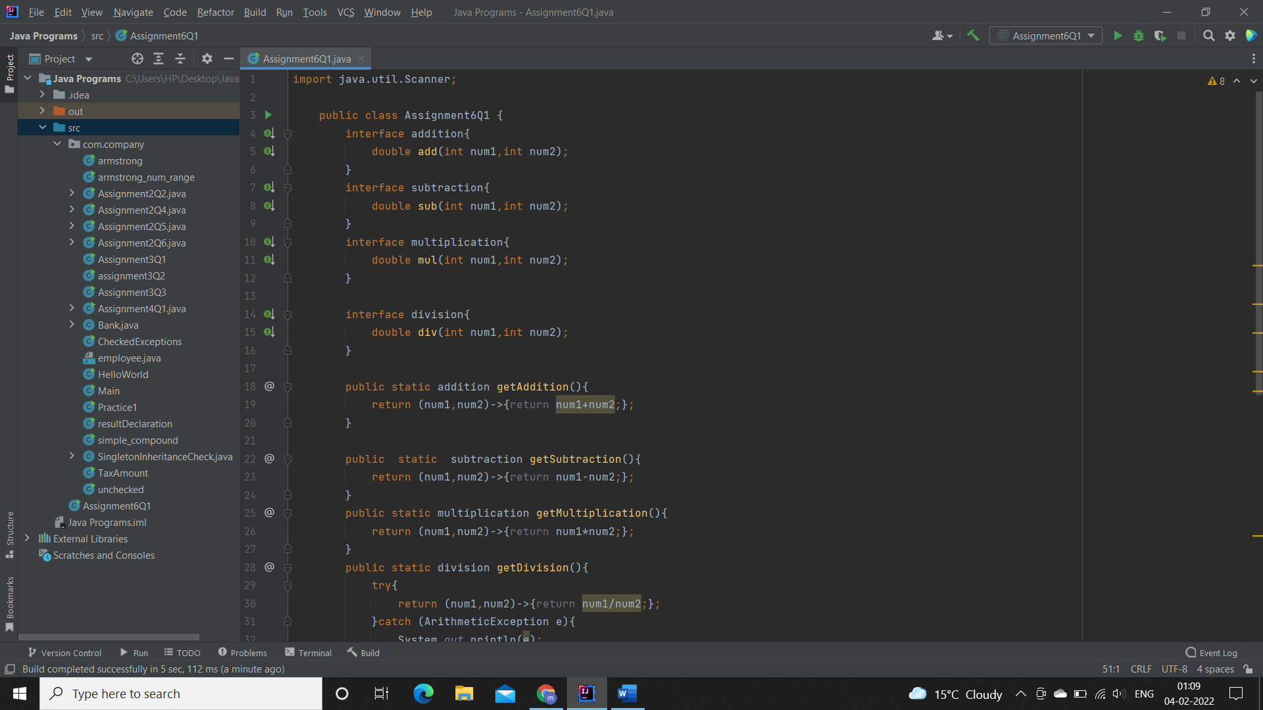

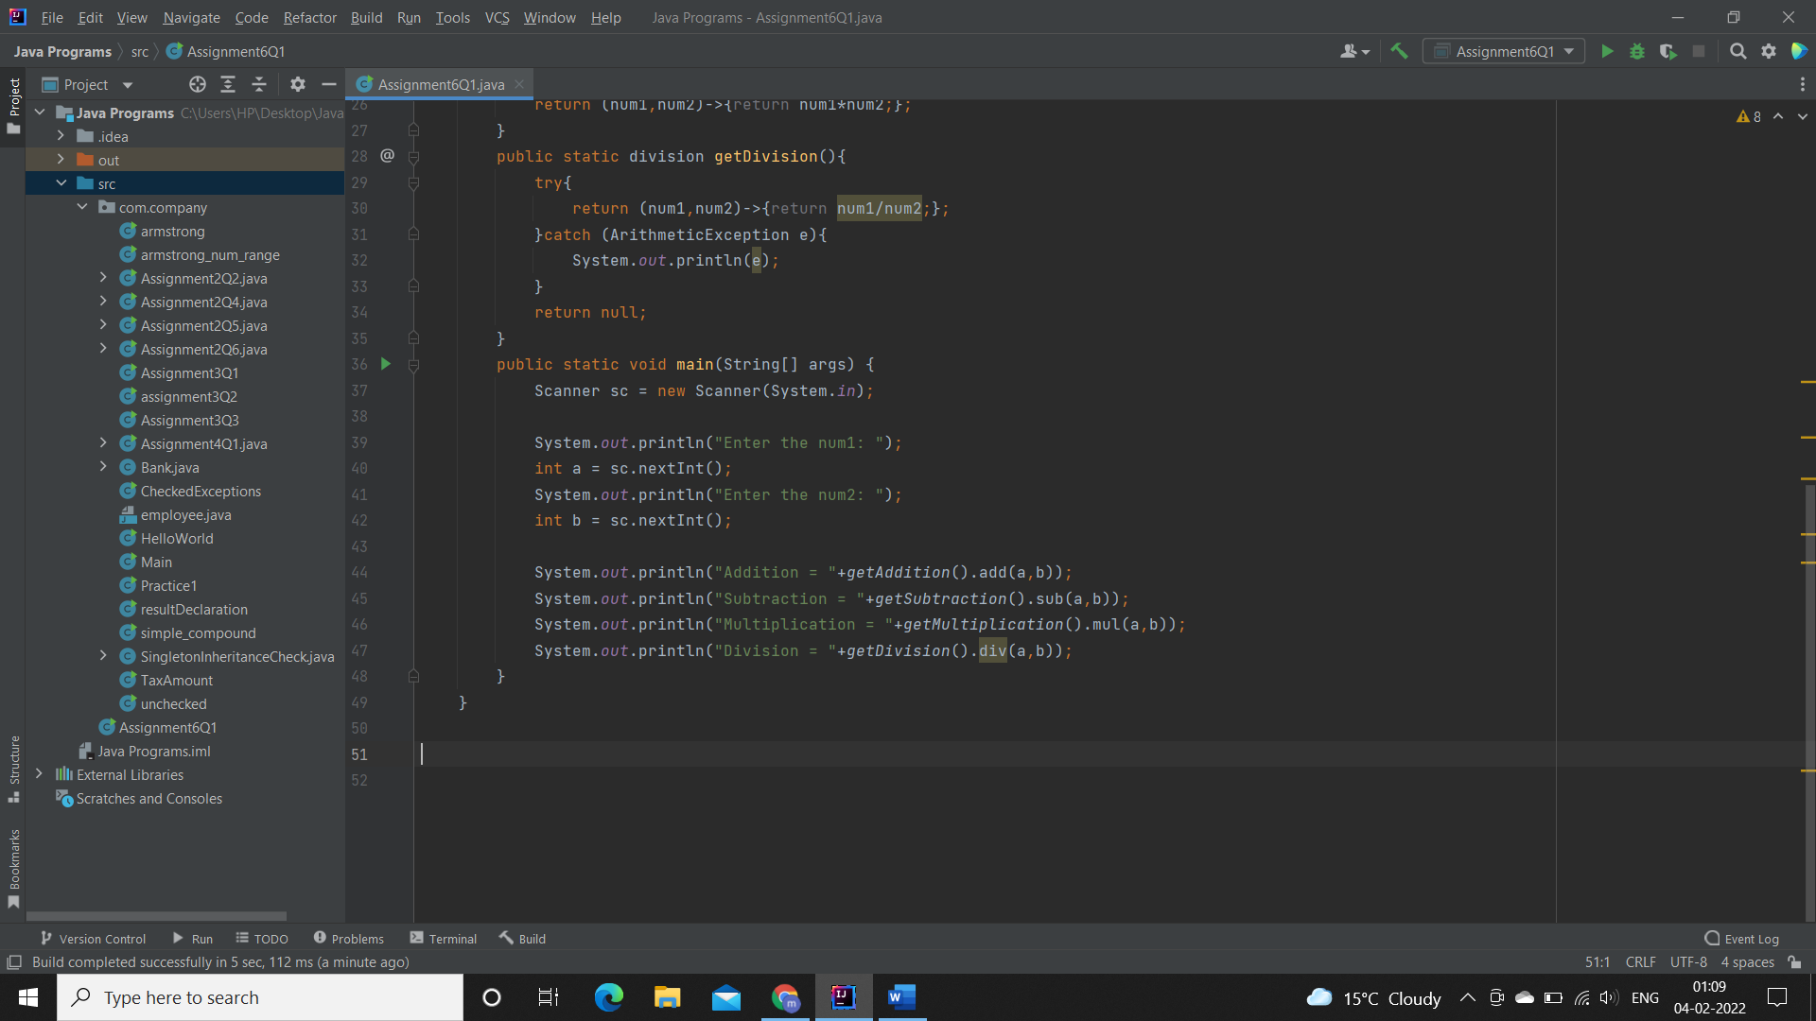

**Output:**

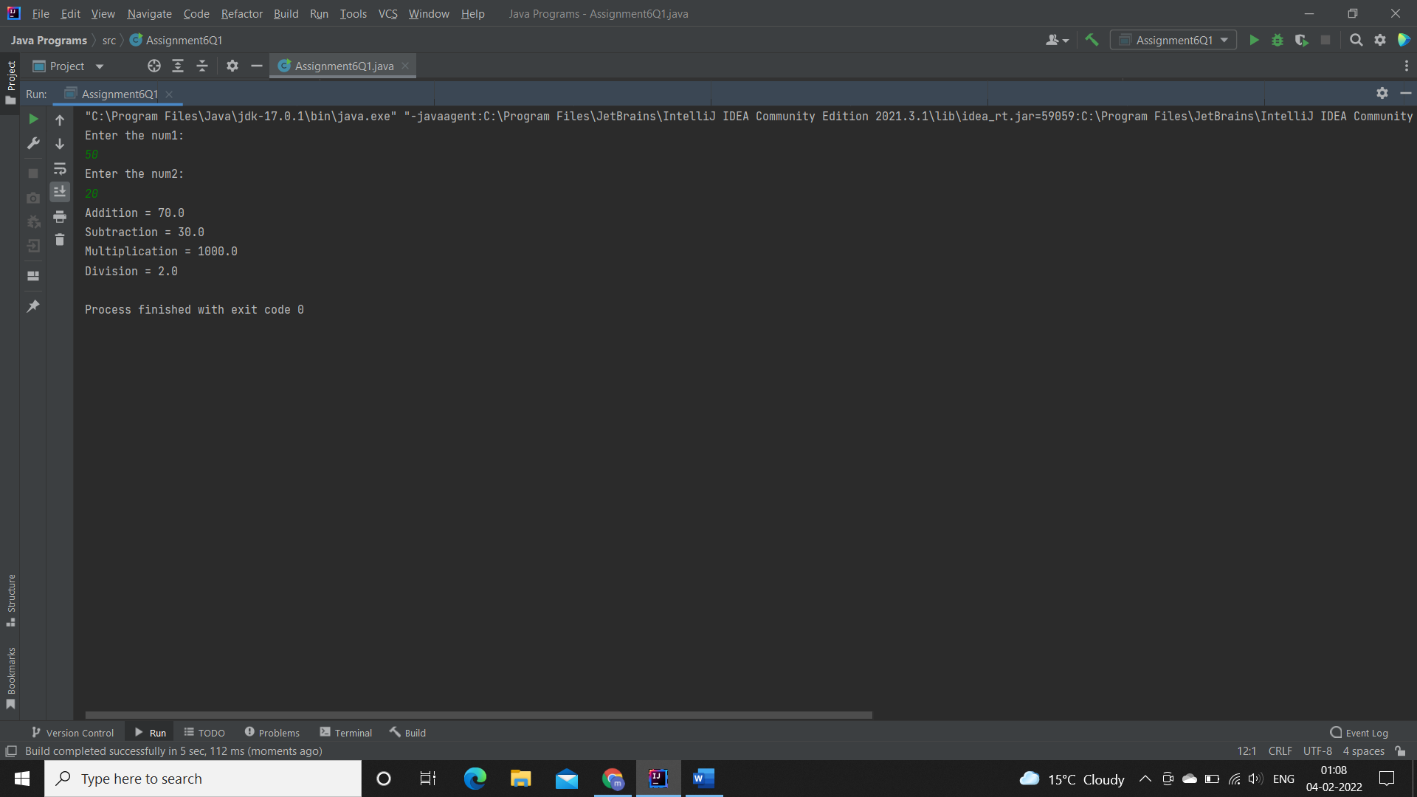

**Q2. Write an application using lambda expressions to print Orders having 2 criteria implemented: 1) order price more than 10000 2) order status is ACCEPTED or COMPLETED.**

**Description:**Write a program in such a way that it has a method which returns the list of orders satisfying the 2 conditions mentioned in the question.

**Specifications:**

import java.util.ArrayList;  
  
public class Assignment4Q2 {  
  
    private int totalPrice;  
    private String status;  
    public static ArrayList<Assignment4Q2> listOfOrders(ArrayList<Assignment4Q2> orders) {}public static void main(String[] args) {}  
}

**Code**

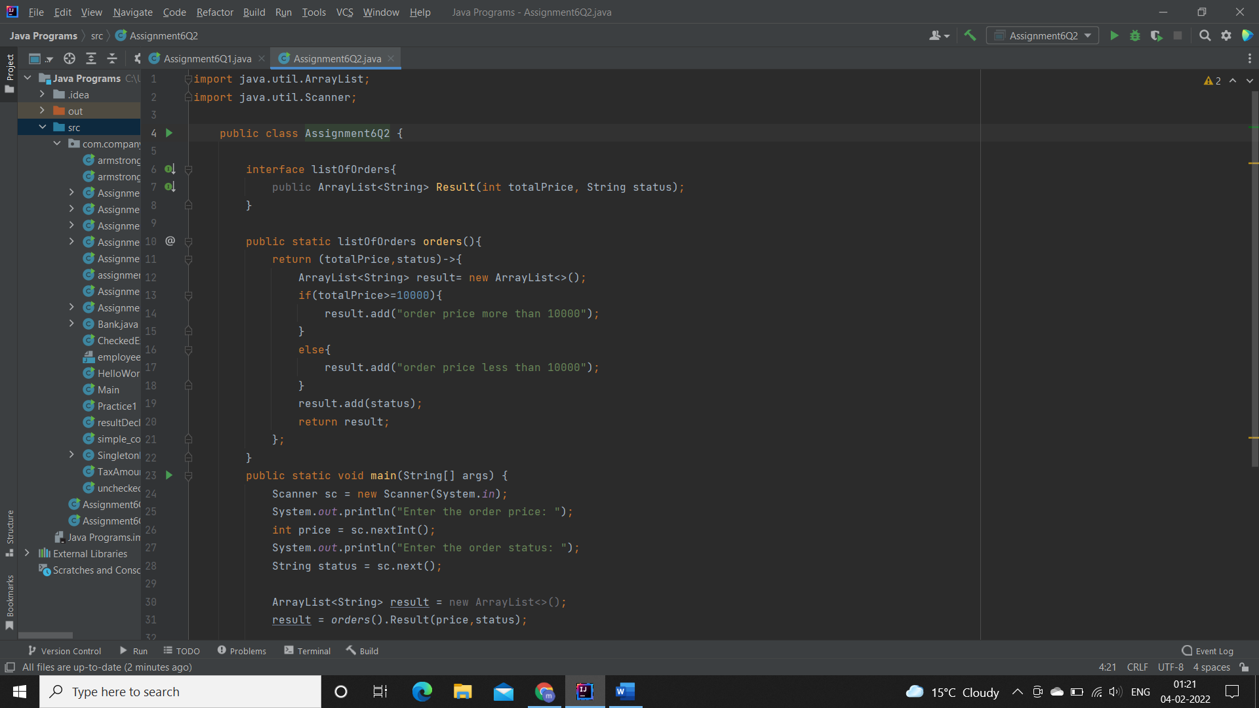

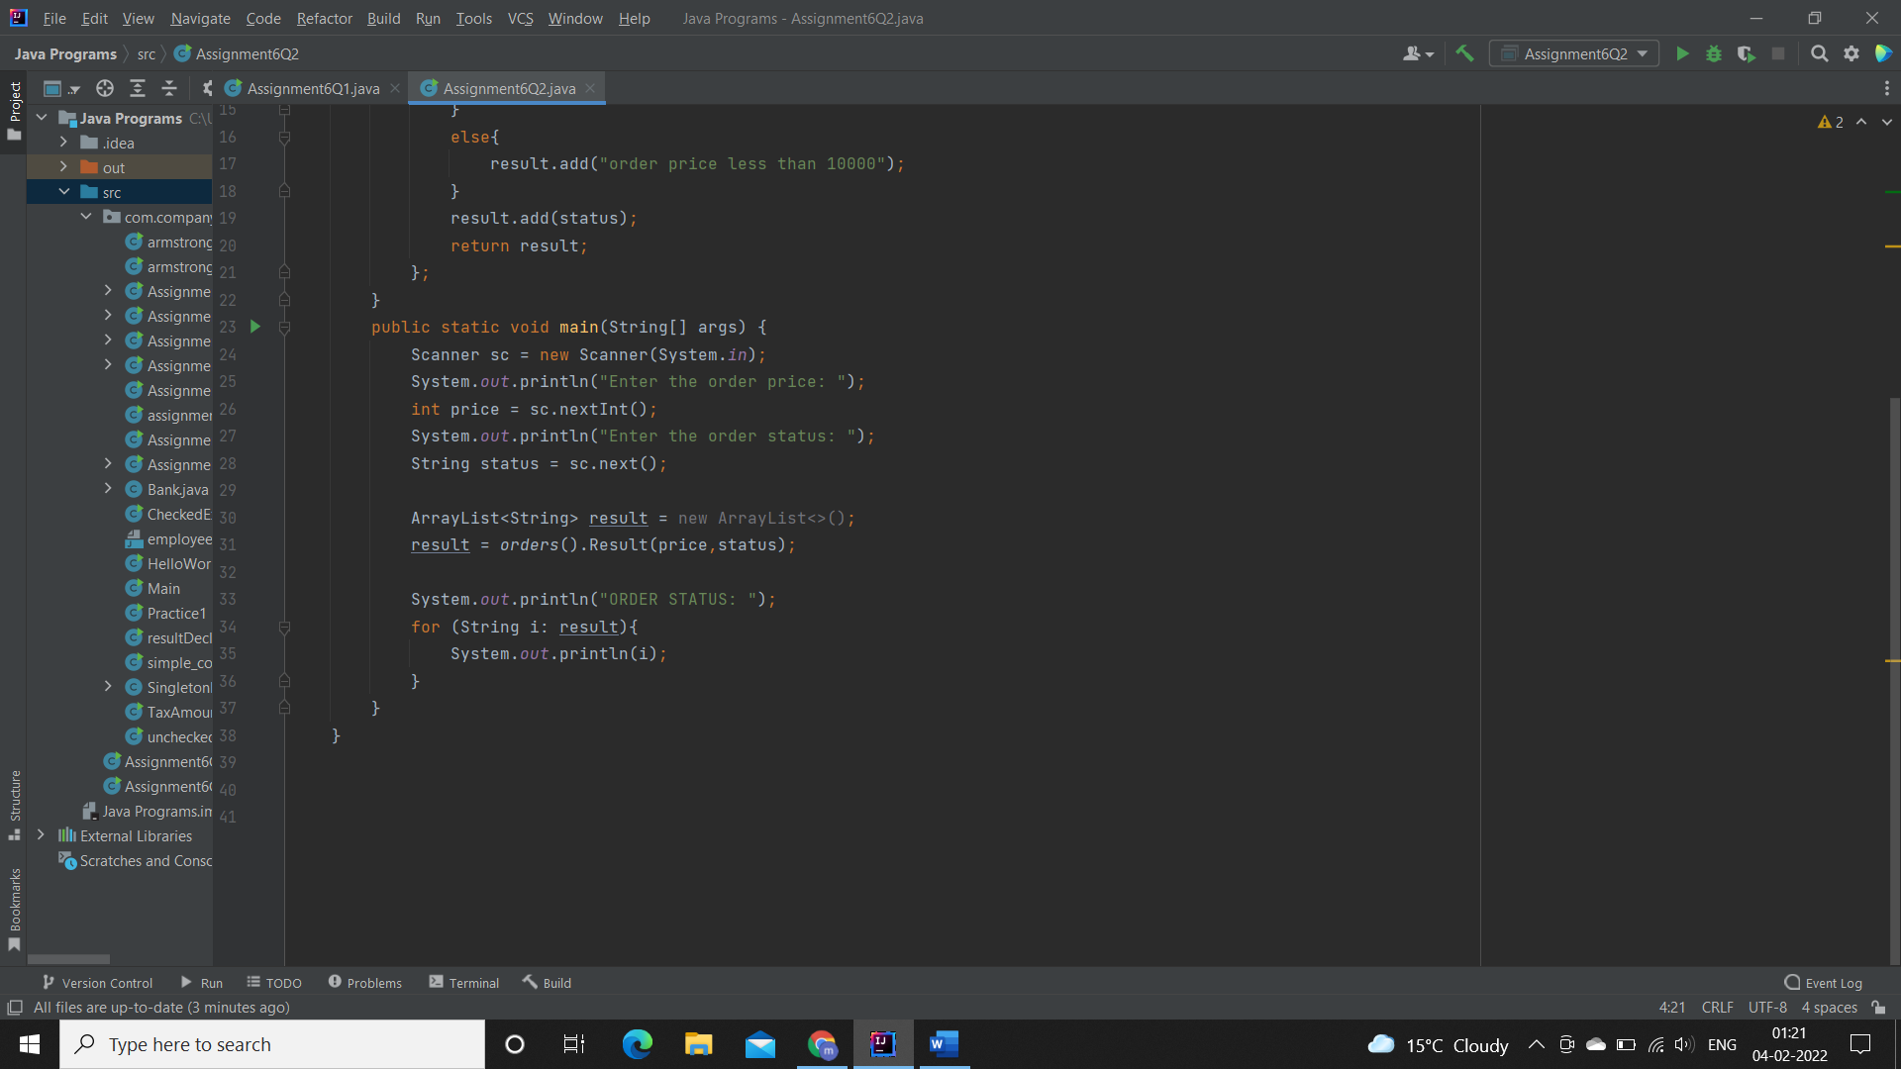

**OUTPUT:**

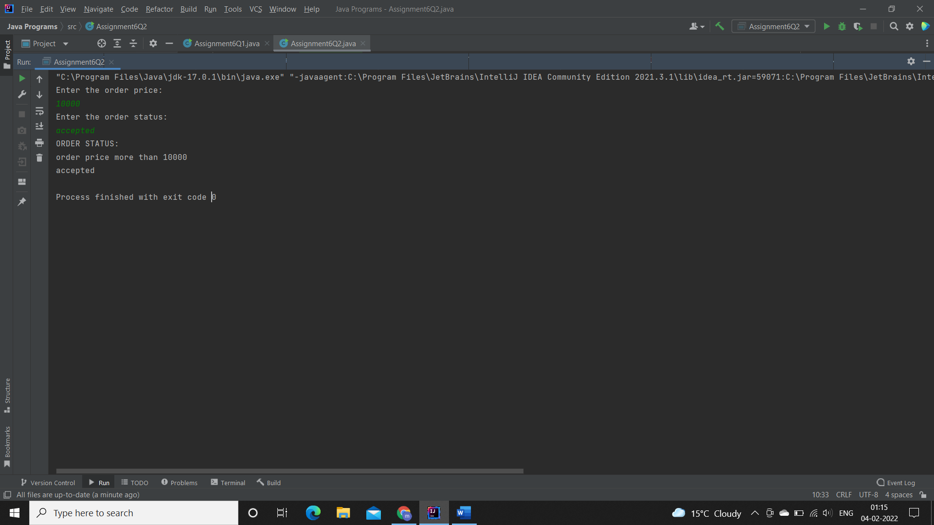

**Q4. Remove the words that have odd lengths from the list. HINT: Use one of the new methods from JDK 8. Use removeIf() method from Collection interface.**

**Description:-**

Write a program using java 8 features which can remove the odd length words from the list.

**Specifications:**

public class Assignment4Q4 {  
    public ArrayList<String> removeOddLength(ArrayList<String> employeeList){}  
    public static void main(String[] args) { }  
}

Code:

import java.util.ArrayList;  
import java.util.List;  
import java.util.Scanner;  
  
public class Assignment6Q4 {  
 interface RemoveOddLength{  
 public ArrayList<String> removeOddLength(ArrayList<String> Employee);  
 }  
  
 public static RemoveOddLength removeOddLength(){  
 return (Employee)->{  
 Employee.removeIf(i -> i.length() % 2 != 0);  
 return Employee;  
 };  
 }  
 public static void main(String[] args) {  
 Scanner sc = new Scanner(System.*in*);  
 ArrayList<String> list = new ArrayList<>();  
  
 System.*out*.println("Enter the numbers of strings to be inserted: ");  
 int n = sc.nextInt();  
  
 for(int i=0;i<n;i++){  
 System.*out*.print("Enter the string: ");  
 String str = sc.next();  
 list.add(str);  
 }  
 System.*out*.println("List before removing odd length words: ");  
 for(String i: list){  
 System.*out*.print(i+" ");  
 }  
 System.*out*.println();  
  
 list = *removeOddLength*().removeOddLength(list);  
  
 System.*out*.println("List after removing odd length words: ");  
 for(String i: list){  
 System.*out*.print(i+" ");  
 }  
 System.*out*.println();  
 }  
}

Output:

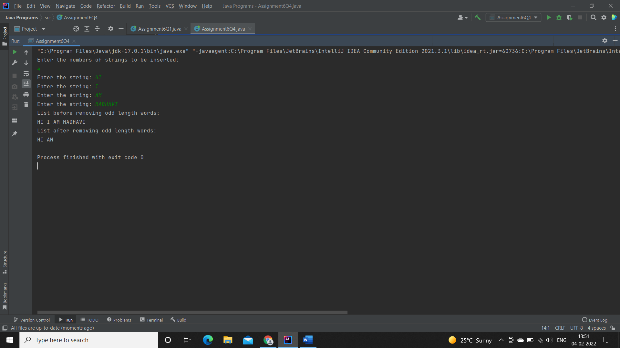

**Q5. Create a string that consists of the first letter of each word in the list of Strings provided. HINT: Use Consumer interface & a String Builder to construct the result.**

**Description:**

Write a java program using StringBuilder and Consumer interface which will return a string. The returned string should consistes of the first let of each word in the list of words.

**Specifications:**

public class Assignment4Q5 {  
    List<String> list = Arrays.*asList*("alpha", "bravo", "charlie", "delta", "echo", "foxtrot");  
  
    public static void main(String[] args) { }  
  
    public static String processWords(List<String> list) {}  
}

**Code:**

import java.util.Arrays;  
import java.util.List;  
  
 public class Assignment6Q5 {  
 static List<String> *list* = Arrays.*asList*("alpha", "bravo", "charlie", "delta", "echo", "foxtrot");  
  
 interface ProcessWords {  
 public String processWords(List<String> list);  
 }  
  
 public static ProcessWords processWords() {  
 return (list) -> {  
 String result = "";  
 for (String i : list) {  
 result += i.charAt(0);  
 }  
 return result;  
 };  
 }  
  
 public static void main(String[] args) {  
 String ans;  
 ans = *processWords*().processWords(*list*);  
 System.*out*.println("String formed by using first letter of each word in the list of words: " + ans);  
 }  
 }

**Output:**

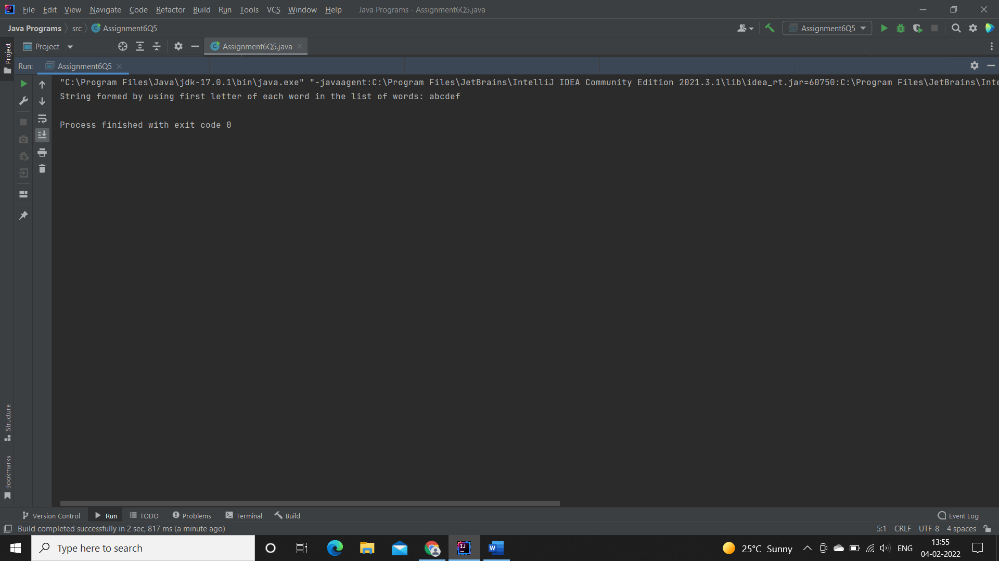

**6. Replace every word in the list with its upper case equivalent. Use replaceAll() method & Unary Operator interface.**

Using replaceAll() method and Unary Operator interface write a java program which replaces evry word in the list with its upper case equivalent.

**Specifications:**

public class Assignment4Q6 {  
    public static void main(String[] args) {}  
    public List<String> convertToUpperCase(List<String> list) {}    
}

**Code:**

import java.util.Arrays;  
import java.util.List;  
import java.util.Locale;  
  
public class Assignment6Q6 {  
  
 interface ConvertToUpperCase{  
 public List<String> convertToUpperCase(List<String> list);  
 }  
  
 public static ConvertToUpperCase convertToUpperCase(){  
 return (list)->{  
 list.replaceAll(i-> String.*valueOf*(i.charAt(0)).toUpperCase()+i.substring(1));  
 return list;  
 };  
 }  
 public static void main(String[] args) {  
 List<String> list = Arrays.*asList*("alpha", "bravo", "charlie", "delta", "echo", "foxtrot");  
  
 System.*out*.println("LowerCase: ");  
 for (String i: list){  
 System.*out*.println(i+" ");  
 }  
 System.*out*.println();  
  
 list = *convertToUpperCase*().convertToUpperCase(list);  
  
 System.*out*.println("UpperCase: ");  
 for (String i: list){  
 System.*out*.println(i+" ");  
 }  
 System.*out*.println();  
  
 }  
}

**Output:**

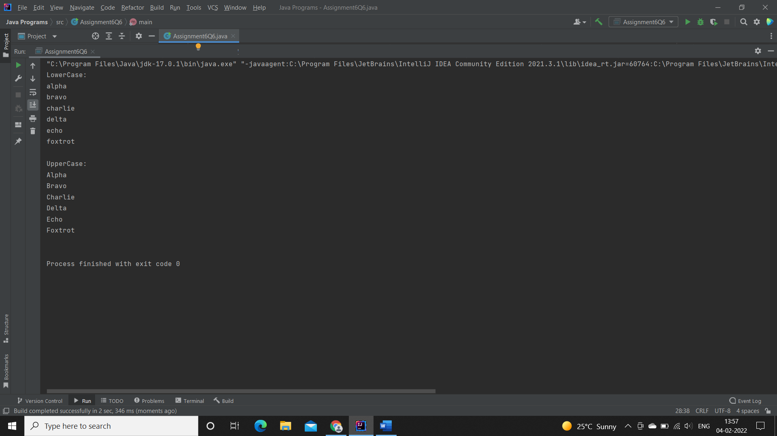

**7. Convert every key-value pair of the map into a string and append them all into a single string, in iteration order. HINT: Use Map.entrySet() method & a StringBuilder to construct the result String.**

**Description:-**

Write a java program using Map.entrySet() method & a StringBuilder which will return a string by appending all the key value pairs of a map into a single string ,in insertion order.

**Specifications:**

public class Assignment4Q7 {  
    public static void main(String[] args) {}  
    public String convertKeyValueToString(HashMap<String, Integer> map) {}  
}

**Code:**

import java.util.HashMap;  
import java.util.Map;  
  
public class Assignment6Q7 {  
  
 interface ConvertKeyValueToString{  
 public String convertKeyValueToString(HashMap<String, Integer> map);  
 }  
  
 public static ConvertKeyValueToString convertKeyValueToString(){  
 return (map)->{  
 String result="";  
 for(Map.Entry<String,Integer> mp: map.entrySet()){  
 String key = mp.getKey();  
 int value = mp.getValue();  
  
 result += key + Integer.*toString*(value);  
 }  
 return result;  
 };  
 }  
  
 public static void main(String[] args) {  
 HashMap<String, Integer> hashMap = new HashMap<>();  
  
 hashMap.put("Madhavi",1);  
 hashMap.put("Adisri",2);  
 hashMap.put("Rishita",3);  
 hashMap.put("Priyanka",4);  
 hashMap.put("Palak",5);  
 hashMap.put("Pradnya",6);  
  
 System.*out*.println("String after append key-value all pairs into a single string:\n");  
  
 System.*out*.println(*convertKeyValueToString*().convertKeyValueToString(hashMap));  
 }  
}

**Output:**

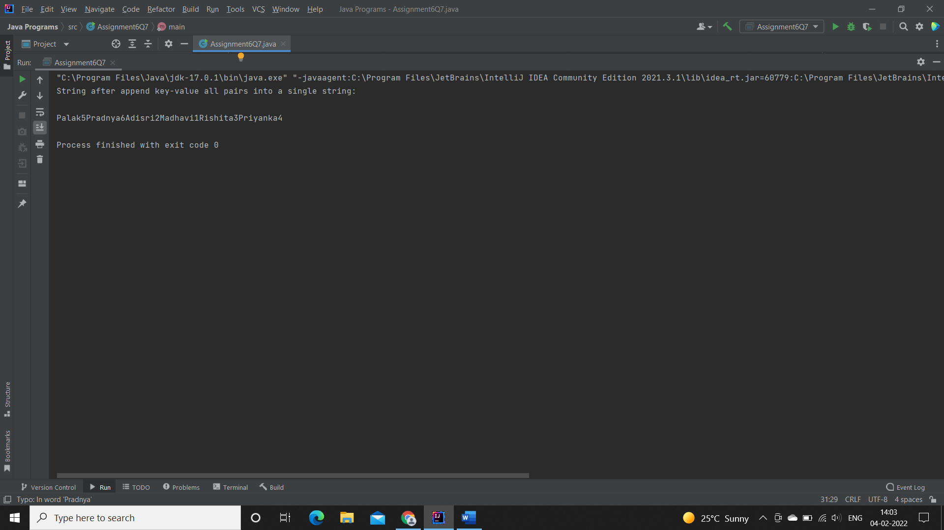

**Q8. Create a new thread that prints the numbers from the list. Use class Thread & interface Consumer.**

**Description:-**

Write a java program which will print the list of number using Thread and interface Consumer.

**Specifications:**

public class Assignment4Q8 {}

**Code:**

import java.util.Arrays;  
import java.util.List;  
  
class Thread extends java.lang.Thread{  
 public void Display_Numbers(List<Integer> list){  
 for (int i:list){  
 System.*out*.print(i+" ");  
 }  
 }  
}  
  
public class Assignment6Q8 {  
 public static void main(String[] args) {  
 Thread thread = new Thread();  
 thread.start();  
  
 List<Integer> list = Arrays.*asList*(1,2,3,4,5,6,7,8,9,10);  
 System.*out*.println("Printing numbers : ");  
 thread.Display_Numbers(list);  
  
 thread.stop();  
 }  
}

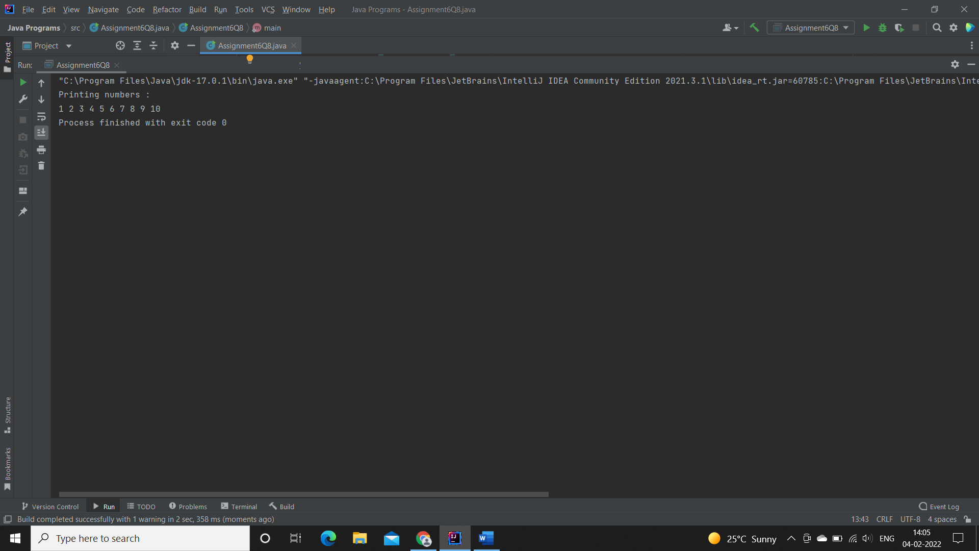**Output:**